**FILE MANAGEMENT SYSTEM**

**ADMINISTRATION MANUAL**

NotFunStuff – Ta Minh Duc

1. Introduction 3

2. Installation Guide 3

2.1. Requirement for installation 3

2.1.1. Hardware Requirements 3

2.1.2. Software Requirements 3

2.1.3. Operating Systems 3

2.1.4.Tools Support 3

2.2. Installation 3

2.2.1. Install IntelliJ + Back-end 3

2.2.2. Install Visual Studio Code + Server 5

# Introduction

The File Management System is a system for managing finance and services.

Using this system is easy, but it assumes that you are familiar with the terms, concepts, and methodologies presented in the File Management System: Admin’s Manual. You should review the document thoroughly before making use of the system.

# Installation Guide

## 2.1. Requirement for installation

### 2.1.1. Hardware Requirements

* Processor (CPU) with 2 gigahertz (GHz) frequency or above
* A minimum of 2 GB of RAM

### 2.1.2. Software Requirements

Browser:

* Chrome* 36+
* Edge* 20+
* Mozilla Firefox 31+
* Internet Explorer 11+ (Windows only)
* Opera GX

### 2.1.3. Operating Systems

* Windows 7, Windows 8 or Windows 10

### 2.1.4.Tools Support

* InteliJ IDE: allow you to run back-end which manage API and work as model and controller.
* Visual Studio Code: allows you to run a server for this system with a browser using an URL like “http://127.0.0.1:5500/”.

## 2.2. Installation

### 2.2.1. Install IntelliJ + Back-end

Step 1: Go to <https://www.jetbrains.com/idea/download/#section=windows>

Step 2: Click download Community Version

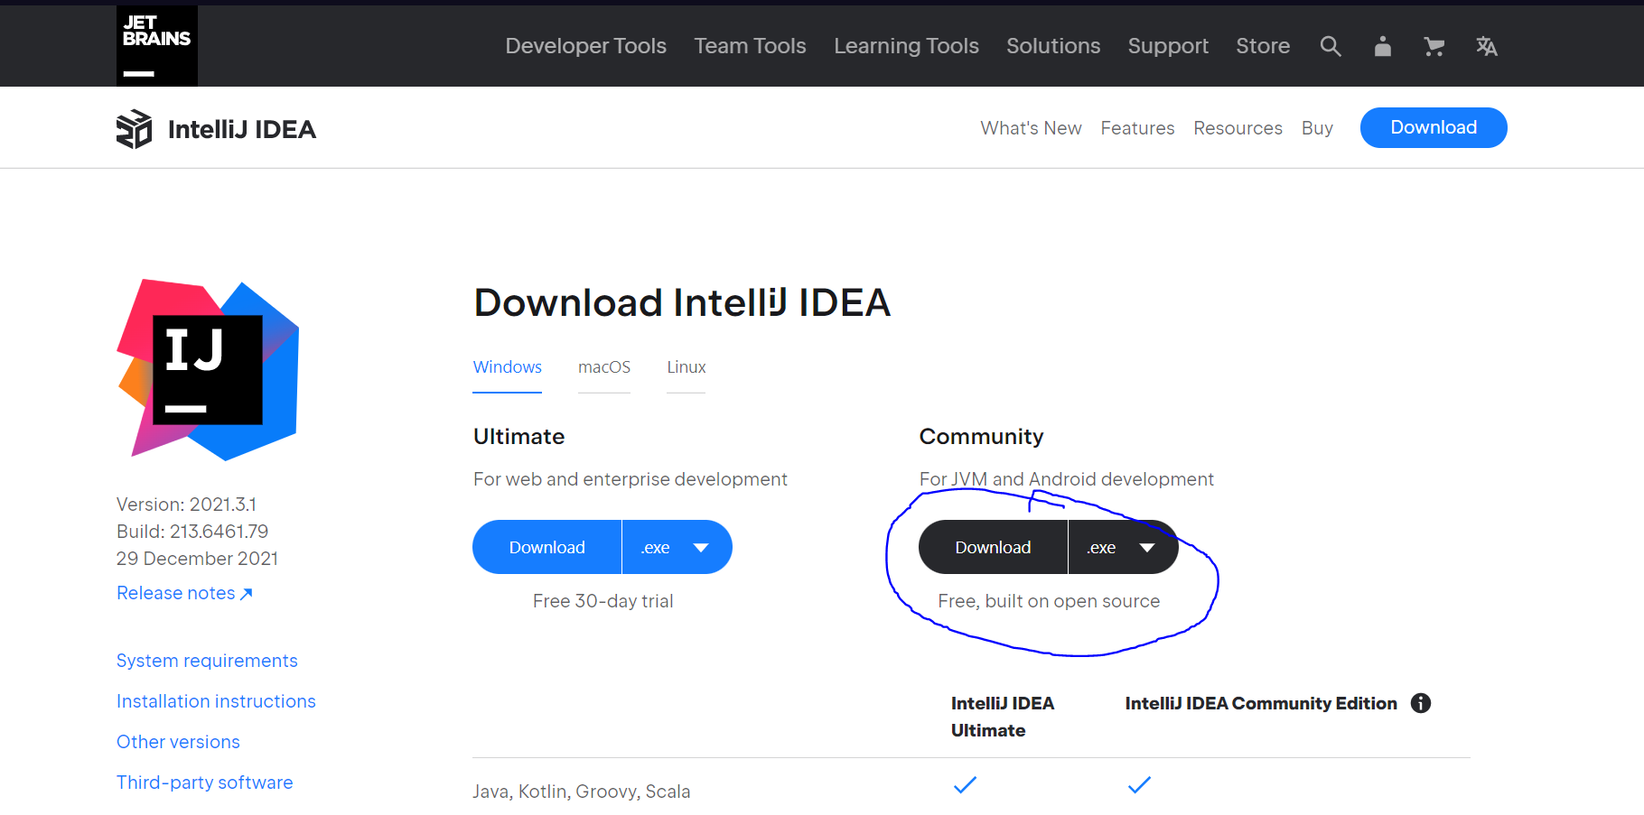

Step 3: Install and run IntelliJ

Step 4: Import file to workspace

Step 5: Run file

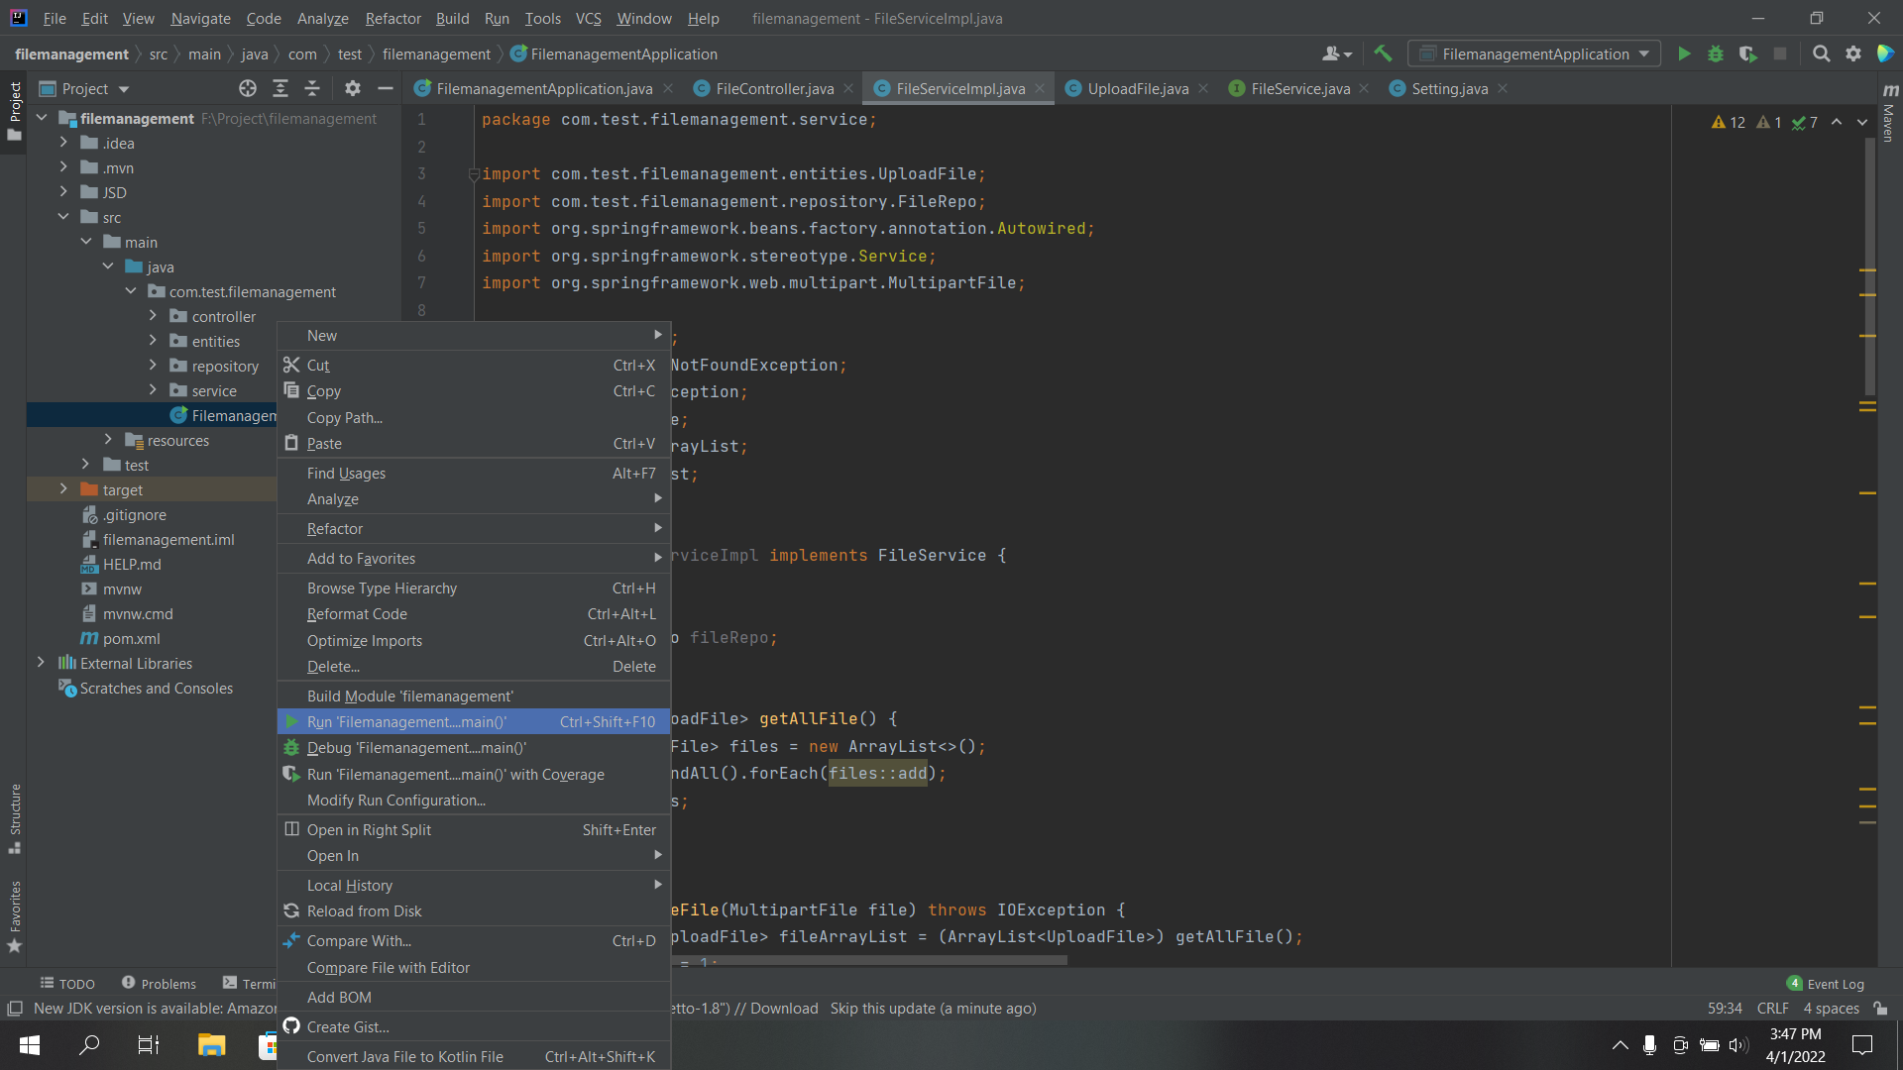

### 2.2.2. Install Visual Studio Code + Server

Step 1: Go to Google, search and download Visual Studio Code

Step 2: After downloading Visual Studio Code, click on Installation setup file to install. (only click Next button)

Step 3: Download Extension Live Server

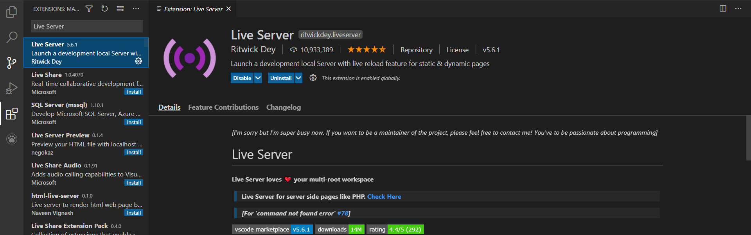

Step 4: open HTML folder and click run live server on addFile.html

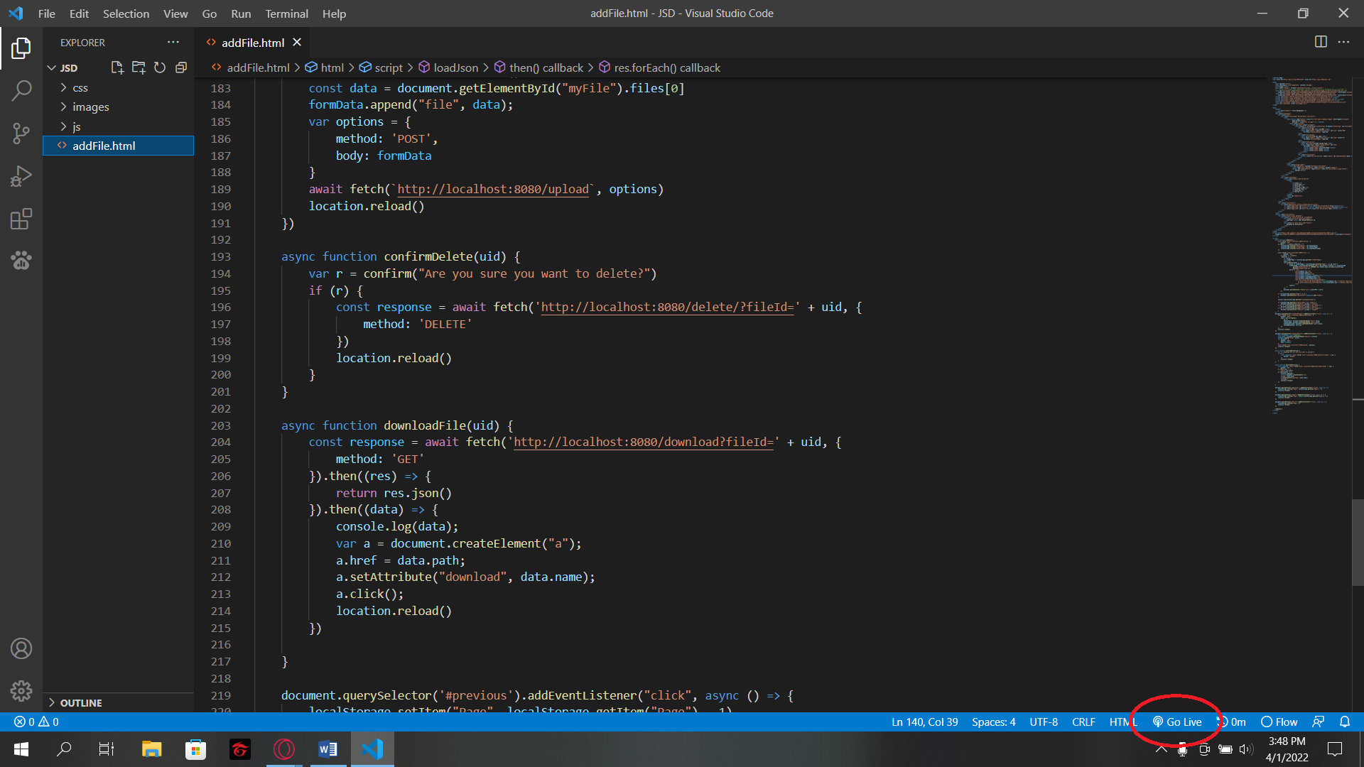

After this step, you can fully use this system.